
MATERNAL HEALTH PROJECT 2010 - 2013

Name of Organization: Sicklecell Association of Uganda Date of Submission: 8th /April /2013

Reporting period: 1st January 2013 to 31st March 2013 District cluster: Mubende Sub county: Nalutuntu
Responsibility | Name | Title | Telephone Number | Email | Signature
Prepared by | Sentamu Edward | Program Officer | 0782963611 | eddiese2002@yahoo.com
Reviewed by | Jackie Nampijja | Acting Executive Director | 0776635515 | jackilove@yahoo.com | 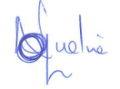
Instructions
- Report data on the meetings where the numbers of attended can be obtained. Also include data where individuals receive messages either in small groups or as individual entities.
Section 1
Introduction

Sicklecell Association of Uganda (SAU) carried out a community dialogue on 5th March 2013 at Kakungube Health center ii areligious based facility. We were joined by UNHCO our cluster partners. The dialogue started at 12:00 – 3: 00 pm facilitated by Mr. Amjad Ssebunya Focal person Nalutuntu.
On 6th March SAU and UNHCO conducted a joint support supervision exercise which took place in all the four parishes in Nalutuntu subcounty these included; Ggambwa, Nalutuntu, Kyakatebe and Kyanamugera. We visited families and asked them about Maternal Health Project however to our disappointment about 20 to 30% had never heard about it and we encouraged the CORPS to widen their scope as they do the individual sensitisation. Challenges identified included; male attendance in meetings, outreaches have not been conducted from January to February, Gender Based Violance is still exising in some home and poor supervision from Focal persons. Recommendations, it was decided and agreed that any sensitisation meeting to take place the area local leaders including LC 1 chairman should participate, about outreaches it was explained that the funds for the outreaches had not been released. CORPS were advised to sensitise people more on the dangers of Gender Based Violance during their meetings. The Focal Persons were advised to conduct maximum close supervision to his CORPS for improved perfomance.
7th March 2013 SAU held a quarterly District meeting with Dr. Jude Kiiza the incharge sub health district whom Dr Wilson Mubiru (DHO) Mubende recommended to settle all issues concerning our areas of implementation. As a team we brought to him the problem of Traditional Birth Attendentants in Nalutuntu, Kiganda and Myanzi who are leading to the death of mothers in these areas. We also addressed to him the unsolved issues on Misozi Health center iii these included; failure of the old incharge to hand over power to the new incharge, late coming of health workers, the community complaint about the health workers attitude and Health workers failure to hand over duty. We also asked him about the completion of Kyakasengula Health center iii in Nalutuntu. Myanzi Hciii power problem and the delay in releasing PHC funds.
Dr. Jude Kiiza explained that the issue of TBA we need to join hands with SAU and UNHCO to fight their practice and this was practically done when he joined us to take some of the leading TBAs in Nalutuntu and Kiganda to police for the crimes committed when they delay mothers in their premises and normally die when they reach in the health centers for example Nnalongo Mulura a TBA in Nalutuntu was taken to police where she made a statement that she will nolonger conduct deliveries in her premises, another TBA from Kasambya was also taken to police for having used a stick to damage the womans uterus when conducting a delivery. Issues concerning Misozi he promised to work hand in hand with the new incharge Kabanda Joseph to solve all the pending unsolved issues on Misozi HC iii. Kyakasengula HC iii in Nalutuntu he promised that very soon it will be opened since it was handed over to the district by the Office of the Prime Minister. Myanzi HC iii power they asked the health workers to fundraise some money for the power in their houses and for the facility the district will cater for the rest of the bill.
As a team we had a radio talkshow on Heart FM Mubende from 6.00 – 7.00 pm the main discussants were Mr. Edward Sentamu (SAU), Mr. Moses Kirigwajjo (UNHCO) and Ms. Kakunda Mable (UNHCO) the main discussion was about the progress of Maternal Health Project in the Kiganda, Nalutuntu and Myanzi subcounties, relating sicklecell and Maternal Health, patient rights, recruitment of Health workers at the District, operation stopping TBA practices in Mubende district, Maternal Health Project activities conducted in Kiganda, Nalutuntu and Myanzi. We had four incalls but all of them were appreciating the the project achievements and asking for a project extension to their subcounties.
8th March the team conducted a dialogue meeting with the Traditional Birth Attendants from Myanzi and Nalutuntu subcounties. There were 15 participants of which we had the Myanzi HC iii incharge, a midwife, Subcounty Health Assistant, Focal person Nalutuntu and Myanzi. The team informed the TBAs about the Government stand on their practice that they should stop conducting any deliveries from their premises. The TBAs wanted the team to inform the village chairpersons to communicate in the village meetings that their services have been terminated. TBAs were also encouraged to work as Village Health Teams to reffer the mothers to Health Centers to be attendend too by qualified health workers. Myanzi subcounty Health Assistant promised to jail any TBA who conducts any delivery at his or her premises. The team had to set to Kasambya village where we went with the media (NTV) to interview one of the TBAs (Nnalongo) who had pluged a stick in a mother and damaged her uterus.
On 9th the team returned to Kampala.
Table 1: Achievements on the targets for the quarter
Result areas/Objectives | Indicator | Actual achievement (numbers ) | Deviation from plan | Reasons for deviation and remedial action
Result 1:  Awareness and demand | Indicator R1.1: Number of community sensitisation meetings held to disseminate MSRHR information | 301 sensitisation meetings were held and these included the following topics;  Gender Based Violence, HIV/AIDS testing, Antenatal care, post natal care, immunisation, Sicklecell and pregnancy, hygiene and sanitation, avoiding Traditional Birth Attendants, Family Planning and male involvement. | We had planned 180 meetings. | - We exceeded our target this was as a result of mobilisation through use of LC chairpersons.
Result 1:  Awareness and demand | Indicator R1.2: Attendances at community sensitisation meetings (groups) | 1491 Males, 2784 Females totalling to 4275 were sensitised on the following topics;  Danger signs of pregnancy, patient rights and responsibilities, Sicklecell and pregnancy, HIV/AIDS testing, Family planning, patient rights and responsibilities, advantages of delivering in Health centres, ANCs, savings for a pregnant mother and sanitation | We had planned 1620 community members. | The attendance exceeded the set target this was as result of more group sensitisation meetings conducted.
Result 1:  Awareness and demand | Indicator R1.3: Attendances for individual information and dialogue with MHP community resource persons (individuals) | 932 Males, 1657 Females totalling to 2589 were sensitised on the different topics which included;  ANCs, Family planning, HIV/AIDS testing, avoid TBAs, patient rights and responsibilities, dangers of abortion and early pregnancy, PMTCT, Sicklecell and pregnancy | We had targeted 1000 individual members | We exceeded the set target this was as result of the frequent home to home visit.
Result 2:  Access and utilisation | Indicator R2.1: Number of outreaches conducted | Response from UNHCO
Result 2:  Access and utilisation | Indicator R2.2: Number of health facilities supported to conduct MSRH service and information outreaches | Response from UNHCO
Result 2:  Access and utilisation | Indicator R2.8: Maternal deaths recorded at community level | Response from UNHCO
Result 3: Accountability | Indicator R3.1: Number of health unit management committees sitting at least 4 times a year. | Response from UNHCO
Result 3: Accountability | Indicator R3.4: Number of health facilities (Health Centre 3 or 4) with at least one functional feedback/redress mechanism in place (i.e. Complaint desks, suggestion boxes, disciplinary committees, meetings etc). | Response from UNHCO
Table 2: Cumulative progress to date (Total numbers since start of the project to the time of current reporting)
Result areas/Objectives | Indicator | Cumulative achievement (numbers ) | Comments
Result 1:  Awareness and demand | Indicator R1.1: Number of community sensitisation meetings held to disseminate MSRHR information | 852 sensitisation meetings held and the topics include;  Danger signs of pregnancy, patient rights and responsibilities, Sicklecell and pregnancy, HIV/AIDS testing, Family planning, patient rights and responsibilities, advantages of delivering in Health centres, ANCs, savings for a pregnant mother, danger of early pregnancy, abortion, post abortion care, postnatal care, male involvement and sanitation. | A tremendous increase in the number sensitisation meetings this is due to the support provided by the local authorities and these include LC chairmen, councillors, parish chiefs and village role models during mobilisation.
Result 1:  Awareness and demand | Indicator R1.2: Attendances at community sensitisation meetings (groups) | 10973 attendances for group sensitisation and topics covered include;  Danger signs of pregnancy, patient rights and responsibilities, Sicklecell and pregnancy, HIV/AIDS testing, Family planning, patient rights and responsibilities, advantages of delivering in Health centres, ANCs, savings for a pregnant mother, danger of early pregnancy, abortion, post abortion care, postnatal care, male involvement and sanitation | An increase in the group sensitisation meetings has been noticed this is because of an increment in the facilitation of CORPS. However male turn up is still low.
Result 1:  Awareness and demand | Indicator R1.3: Attendances for individual information and dialogue with MHP community resource persons (individuals) | 6256 individual members sensitised on the following topics;  Danger signs of pregnancy, patient rights and responsibilities, Sicklecell and pregnancy, HIV/AIDS testing, Family planning, patient rights and responsibilities, advantages of delivering in Health centres, ANCs, savings for a pregnant mother, danger of early pregnancy, abortion, post abortion care, postnatal care, male involvement and sanitation. | There is also an increase in the individual sensitisation meetings this is as a result of during home to home visit we always target both females and males.
Result 2:  Access and utilisation | Indicator R2.1: Number of outreaches conducted | Response from UNHCO
Result 2:  Access and utilisation | Indicator R2.2: Number of health facilities supported to conduct MSRH service and information outreaches | Response from UNHCO
Result 2:  Access and utilisation | Indicator R2.8: Maternal deaths recorded at community level | Response from UNHCO
Result 3: Accountability | Indicator R3.1: Number of health unit management committees sitting at least 4 times a year. | Response from UNHCO
Result 3: Accountability | Indicator R3.4: Number of health facilities (Health Centre 3 or 4) with at least one functional feedback/redress mechanism in place (i.e. Complaint desks, suggestion boxes, disciplinary committees, meetings etc). | Response from UNHCO
Note: For indicators; R2.2, R3.1 and R3.4; the cumullative will initially increase, once the total maximum number available is reached there will be not cummulatives, instead the the number will remain the same if there are no declines.
Table 3: Mass Media
Type | Number | Topic/Theme
Eg Radio talk shows  This is a joint activity implemented by both SAU and UNHCO | SAU facilitated three radio talk shows | - We talked about the progress of MHP in Myanzi, Nalutuntu and Kiganda  - Relating Sicklecell and Maternal Health  - Patient rights  - Recruitment of Health workers by the District  - Operation STOPPING TBAS in Mubende.  - MHP activities  - The role of HUMCs
Radio spot massages | 180 | - Encouraging women to go for ANCs, Male involvement and delivering in Health centres.
Drama shows etc | 1 | - Drama show captured these themes; HIV/AIDS prevention and testing, ANCs, VHTs work, Male involvement, bad effects when delivering from a TBA, Health workers attitude, Family planning, getting advice from friends

Section 2: Narrative page
Provide a detailed description on how all activities were implemented per result area and what was achieved as a result of implementing the activities.
2.1 Result area1: Target communities aware of their rights and demand quality MSRH services
Community Dialogue was carried out on 5th Mar 2013 at Kakungube HC ii Nalutuntu Sub County a religious based facility affiliated to Uganda Muslims Supreme Council.
Before the Community Dialogue we interacted with the Deputy In charge Mr. Sekidde Hassan where he explained that the health facility has nine (9) HUMC members who sit once a year. They have a maternity ward, a youth corner, an emergency ward, Outpatient ward and post delivery ward.
There is an increase in the number of deliveries as he said “We Used to deliver 3 mothers a month but now we deliver 7 mothers”. This led to an expansion of a maternity ward at this health facility.
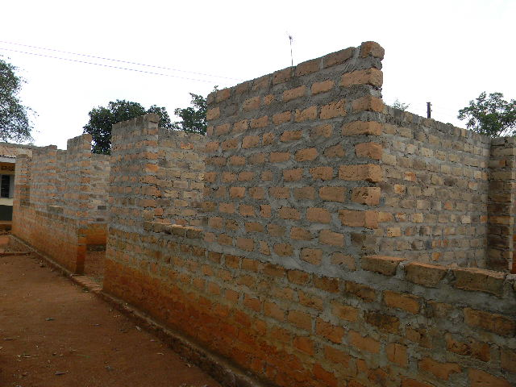
A photo showing an expansion of the Maternity Ward at Kakungube HCii Nalutuntu S/C
He emphasised that the Subcounty health coordinators have not been invited in District planning meetings so as to help in the improvement of the Primary Health Care
86 participants attended the dialogue from 12:00 – 3:00 pm facilitated by SAU focal person Amjad Ssebunnya
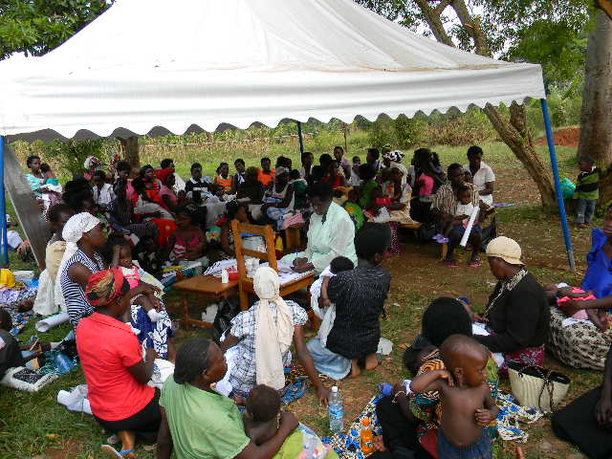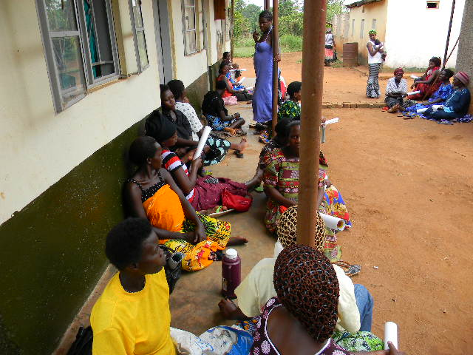
Participants at Kakungube HCii community Dialogue submitting their views to the group facilitator. Mothers had also come for Antenatal care at the facility

Comments
- Chairman LC1 Chairman Mr. Abbas Senabulya Ssalongo requested to e helped with the challenge of TBAs who are still prevalent in the parish and recommended that the TBAs should refer these mothers quickly to the Health centres.
- To this the Subcounty chief commented that TBAs are not even recognized by the Ugandan Health Care system and therefore should not be allowed to practice. This was seconded by the VHR team and Focal persons.
- He also pledged to have a meeting with Traditional Birth Attendants, Local herbalists and the LC chairpersons at the Subcounty Head offices.
- Mr.Sekidde Hassan Deputy in charge in Kakungube HCii (0753420497)reported services available at the facility included; immunisation, Health Education, ANCs, youth friendly services but also mentioned that they were facing the following challenges
- Lack of Water at the maternity ward
- Delay of Primary Health Care funds
- Long distance with no means of transport to reach out to the community.
- Increase in teenage pregnancy due to poverty and long distance to schools
- HUMCS meet only when funds are available
Follow up issues from previous dialogues which were held at Mirembe HCii and Ggambwa trading centre last year.
This session was facilitated by Mr. Edward Sentamu Program Officer SAU and these were the responses from the Subcounty chief Nalutuntu.
- Health Unit Management Committee at Mirembe HC ii is now functioning and it sits four times a year.
- Renovation of Mirembe HC ii funds are now in the financial budget of 2013/2014 come next year the renovation would have been accomplished. This came out from the Mirembe community dialogue where the community demanded the renovation of their HC ii.
- Health center iii is now completed by the Office of the Prime minister and handed over to the district.
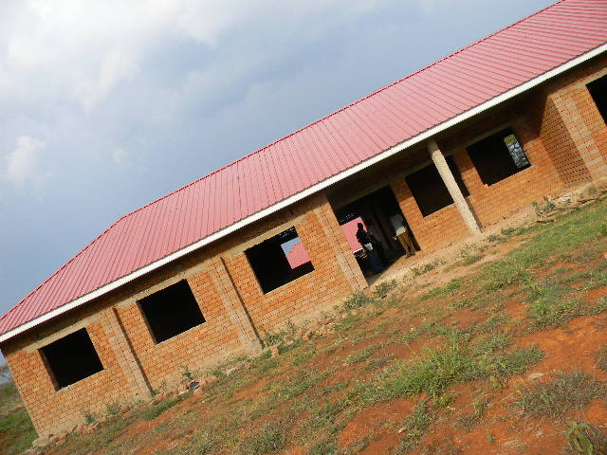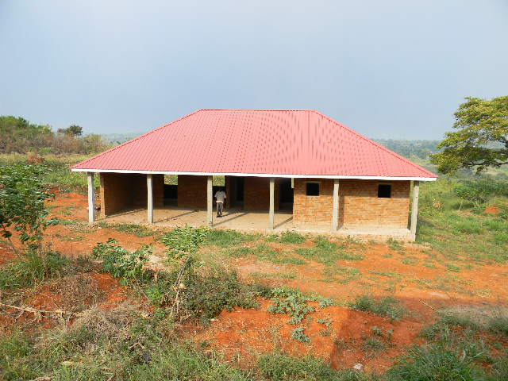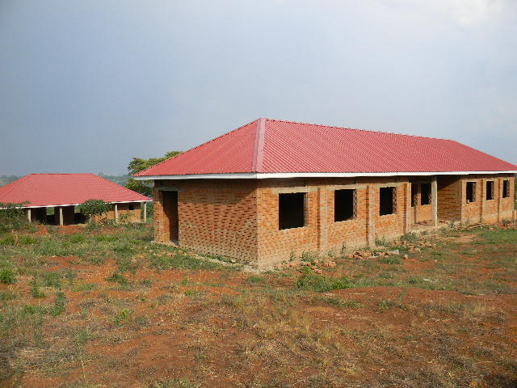
Photos showing Nalutuntu HCiii which has been constructed by Office of the Prime Minister.
- Our CORP Ms Mbatudde can now access family planning drugs from Myanzi HC iii this was because in the last dialogue held in Ggambwa trading centre she had complained about Family planning drug stock outs yet she provides those services in her parish. There is ow enough provision of drugs in Myanzi HCiii.
Issues from the Community
- Men do not provide for their wives when there are pregnant
- Drug stock outs from Health centres
- Poor hygiene among families
- Lack of water at kakungube HC ii in the maternity ward
- Domestic violence at their homes
- Why do they sale Mama kits to us
- Males fear an HIV/AIDS test.
- Some Health workers attitude is still poor.
- Why Kakungube HC ii does not conduct male circumcision yet he is Muslim based Health centre?
- Where do you refer your patients in case of emergences
- Our wives often go for ANCs but end up delivering from TBAs
- What should we do to our husbands who do not want to support us during pregnancy?
Responses from Subcounty chief, Health Assistant, Community Development Officer, in charge Kakungube HC ii, CORPS, Focal person, UNFPA representative, Vice Chairperson LC iii Nalutuntu S/C
- Sub county chief emphasized that Communication in marital relationship should be improved to change the outcomes and obtain successful maternal Health.
- Men and women were encouraged by the S/C health Assistant to save money for preparations during and after delivery since pregnancy do not appear as an emergency.
- About drug stock out, Sub County Chief encouraged the in charge to inform community about them so as to reduce the unexpected demand and this can be done by pinning up a manila chart with the drugs and services available at the facility.
- The Health Assistant informed the community that the Health workers have changed their attitude positively. She gave a practical example of midwives at Kiganda HCiv whom everyone is appreciating their good services provided to them. She even told them that in Nalutuntu most Health centres are private therefore in case they ask money from you do not hesitate to pay.
- Women and men were encouraged to work together and ensure good hygiene for the female counterparts this was evidenced when LC iii vice chairperson said that most women fear to go and deliver in these Health centres because of their bodies are dirty.
- Power has been connected to Kakungube Health center ii by the Member of Parliament Hon Nyombi Thembo this was due to the community demand for quality services at the facility.
- The chief said that since Nalutuntu subcounty as per now we do not have a functioning Health centre iii we only resort to Health centre iis and yet some are private therefore the in charge is responsible to inform the community that some services are paid for.
- About TBAs the Subcounty Chief informed the community that his to call up a TBA meeting to inform them that the government can no longer accept their services and therefore it’s a criminal offence to carry out any deliveries at their premises.
- The Subcounty chief also informed the Health workers those men who accompany their wives to health centres need to show them as role models to other women so as they can also encourage their husbands to accompany them.
- About HIV/AIDS testing the in charge Kakungube HCii advised mothers whenever they want their husbands to come for a test, they need to improve their communication, instead of telling their husbands that “the Health Workers want to see you”. This will instead scare them away.
- The in charge informed the community that male circumcision is being conducted at this health facility therefore in case they want their husbands to come for SMC let them be informed.
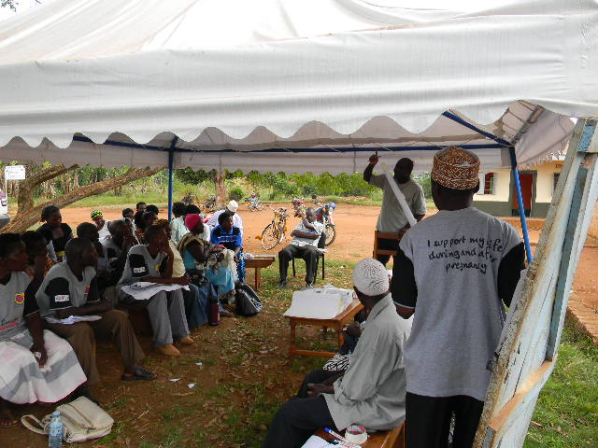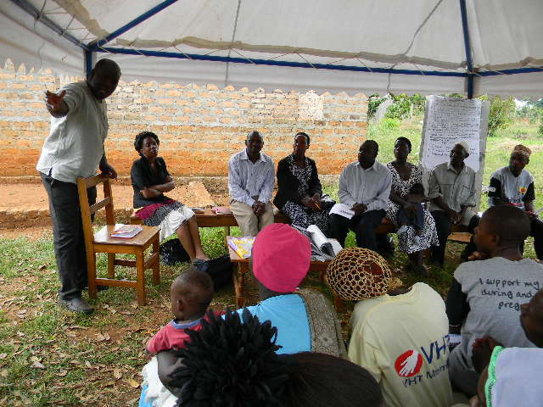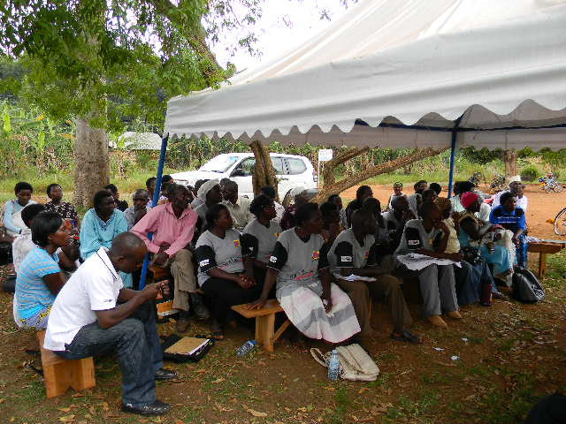
Participants in the community dialogue and Subcounty official these include; Subcounty chief, LC iii Vice chairperson, Community Development Officer, Subcounty Health Assistant, LCi Chairman, Subcounty and district Councillors

On 6th March the team conducted a support supervision in all Nalutuntu parishes these included; Ggambwa, Nalutuntu, Kyanamugera and Kyakatebe. We agreed that we needed to interview the community (beneficiaries) about the Maternal Health Project, whether they attend sensitisation meetings, do resource persons approach them during individual sensitisation?, about listening to Maternal Health radio programs, whether they attend outreaches, services provided at a health facility. These were some of the gaps identified during the support supervision; limited male attendance in meetings and this was coupled by the men minimising some CORPS, outreaches have not been conducted from January to February, Gender Based Violance is still exising in some homes, five CORPS are not easily identified by the community, when mothers go to deliver from Mityana Hospital they are sent away because they are from Mubende district causing a delay, some parishes donot even have Health center iis therefore there are long distances to travel from the village to a nearby health center and limited supervision from Focal persons to CORPS.
Recommendations, it was decided and agreed that any sensitisation meeting to take place the village chairman must attend or his representative, we greed to conduct a dialogue with Mityana Hospital with our Implementing partners in the district (Mental Health Uganda and Reproductive Health Uganda) about the the issue of sending away mothers back to Mubende Hospital. Parishes without Health center iis we lobbied the subcounty to include this in its Budget. About outreaches it was explained that the funds for the outreaches had not been released but now since the funds are available outreaches must be conducted supervised by the Focal person and as ateam we attended an outreach which was facilitated by UNHCO at Nkandwa village Nalutuntu. CORPS were advised to sensitise people more on the dangers of Gender Based Violance during their meetings because it was discovered that domestic violance still persists among the community. The Focal Persons were advised to conduct maximum close supervision to their CORPS for improved perfomance which they agreed to do.
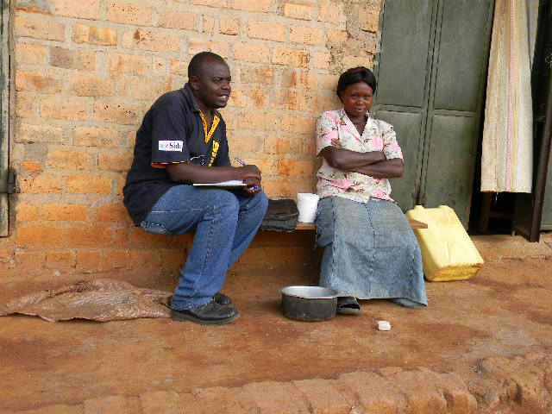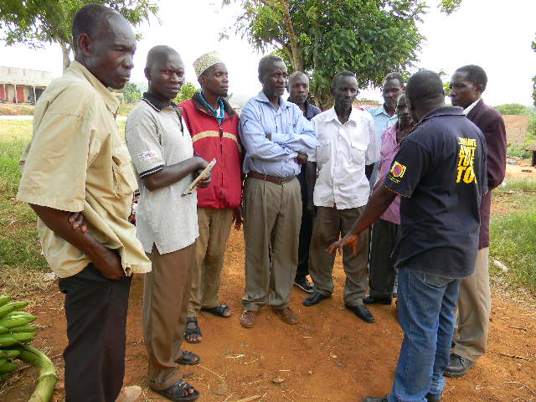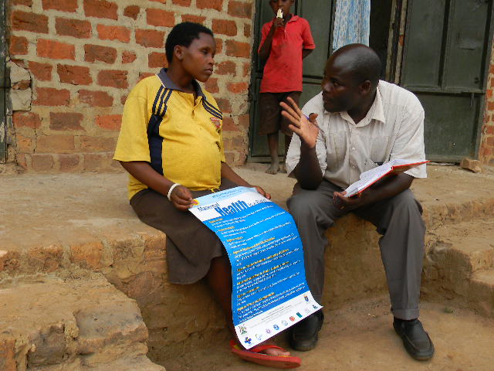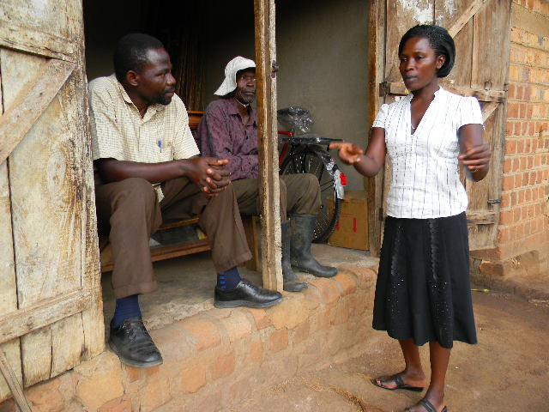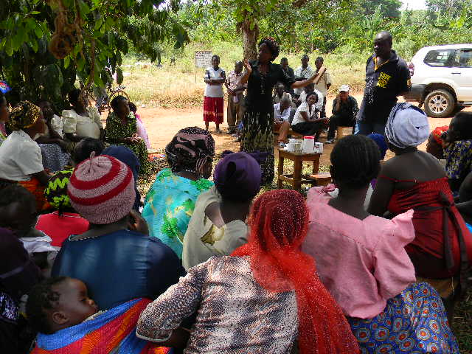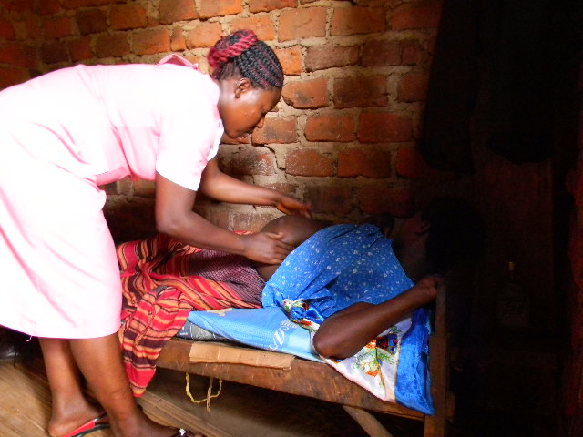
Support supervision was conducted jointly as acluster sampling randomly homes in all the four parishes of Nalutuntu S/C. We also attended one outreach at Nkandwa village Nalutuntu faciliated by UNHCO
7th March SAU, UNHCO and Chairman for Health Management Committee Kiganda HCiv visited Misozi Health Center iii and conducted a dialogue with the health workers and identified some challenges with this health center and these included; failure of the old incharge to hand over power to the new incharge, late coming of health workers, the community complain about the health workers attitude and Health workers failure to hand over duty instead they just vacate the facility and the patients suffer, the community must be sensitised on how to use suggestion boxes and more sensitisation meetings need to be conducted by the CORPS.
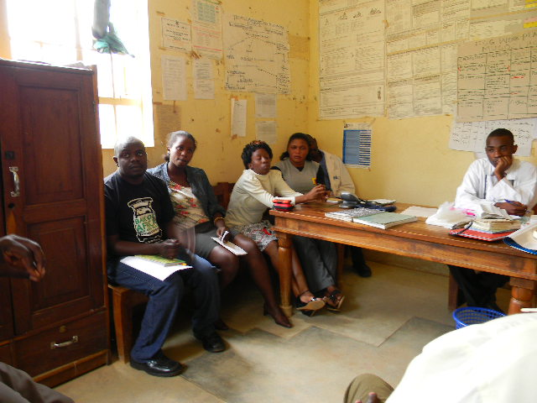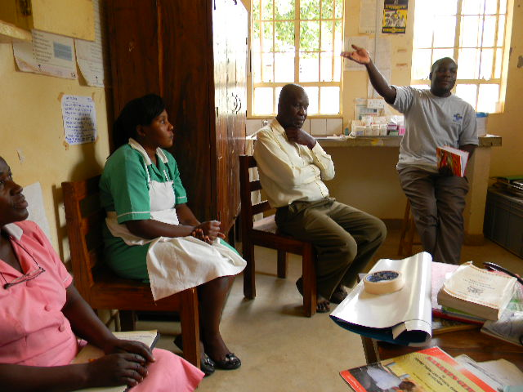
Mubende cluster conducting a dialogue with Health workers at Misozi HCiii
The team further went to visit one of the leading TBA in Nalutuntu (Nnalongo Mulura) we were accompanied by the In charge Sub Health District Dr. Kiiza Jude, Nalutuntu sub county chief, Chairman HUMC Kiganda, a midwife from Kiganda (Nurse Asaba) and the focal persons. This TBA was taken to Kakungube police station and made a statement for having delayed a mother and died on her way to a Hospital and also to stop conducting any deliveries from her premises.
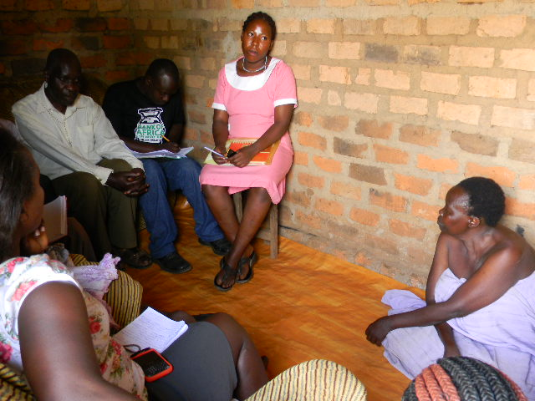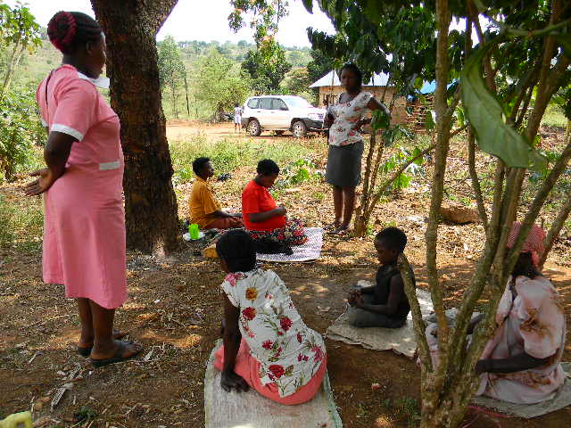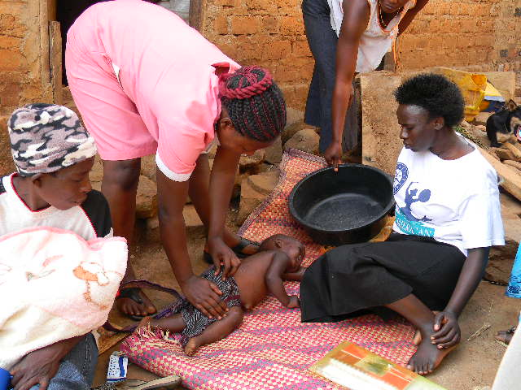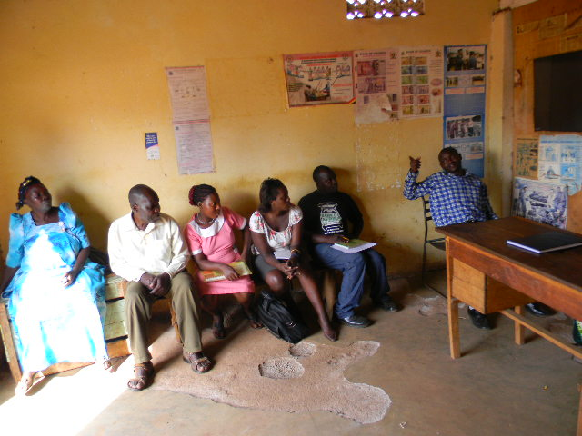
The team at a TBAs home Nnalongo Mulura, a midwife sending mothers to Kiganda Hciv for delivery from Nnalangos compound, a midwife providing first aid to a child convulging at Nnalongos home and at Kakungube police statition.
We later convined for a quarterly district stakeholders meeting where Dr.Jude Kiiza was mandated by the DHO Mubende (Dr. Mubiru Wilson) to be the appropriate person to submit in all our complaints and also for lobbying purposes at district level. The team introduced its self to him once again and briefly talked about the progress of Maternal Health Project in all the three subcounties that is Kiganda, Nalutuntu and Myanzi. We addressed to him all the challenges faced by Misozi HC iii, the completion of Kyakasengula HC iii in Nalutuntu and the issue of mothers dying from TBAs in all the three subcounties.
Recommendations; He commended that since now he was given a new responsibility by the DHO Mubende as the (Incharge Sub Health District) he pledged to support the new incharge in Misozi Hciii to change the face of the facility. Nalutuntu Hciii has been completed by the Office of the Prime Minister and it has now been handed over to the District for implementation and very soon we hope it will be opened. About TBAs he promised to give us all the support the team needs and he will work very closely with us as the operation continues of stopping TBAs from conducting any deliveries at their premises.
Radio talk show on Heart FM Mubende at 6.00 – 7.00 pm the team held a radio talk show on Heart FM and the main discussants were Mr. Edward Sentamu (SAU), Mr. Moses Kirigwajjo (UNHCO) and Ms. Kakunda Mable (UNHCO) the main themes were about the progress of Maternal Health Project in Kiganda, Nalutuntu and Myanzi subcounties, relating sicklecell and Maternal Health, patient rights, recruitment of Health workers at the District, operation stopping TBA practices in Mubende district, Maternal Health Project activities conducted in Kiganda, Nalutuntu and Myanzi. We had four incalls but all of them were appreciating the the project achievements and asking for a project extension to their subcounties.

8th March, the team conducted a dialogue at Myanzi HC iii with all the Traditional Birth Attendants in both Myanzi and Nalutuntu subcounties. We had ten TBAs, Myanzi HCiii incharge, Myanzi subcounty Health Assistant, a Midwife and the focal persons both from Nalutuntu and Myanzi. There were introductory remarks by Mr. Kirigwajjo Moses (UNHCO) supplemented by Mr. Edward Sentamu (SAU) and Ms. Mable Kukunda (UNHCO). We indicated the government stand on abolition of services conducted by TBAs. Currently if any TBA is caught by police rendering delivery services in his/her premises will be imprisoned. There is an increase of mothers dying from their premises forexample a mother who was delayed from Nnalongos (TBA) premises died with her twins on her way to Mubende Hospital. It was from that statement that the implementing partners and local govermmnet officials stopped all operations carried out in your premises.
Comments from the Traditional Birth Attendants; what should we do because this has been our source of income, these women are poor and do not get any support from their husbands, some times they normally come to us at night what should we do?, If you tell her to go to a health center and refuses to go, do i have to force her?, We are also requesting you to inform the LC Chairpersons to tell those women not to come for our services.
Responses; the incharge Myanzi HC iii told them that their lives and that of the mothers plus a new born are not well protected since they donot have enough equipment to use such as glooves. Mothers who may need a C- section you will not be in position to assist them and the HIV/AIDS will not be prevented from mother to child.
Myanzi Midwife pledged to work hand in hand with them as long as they reffer these mothers to the health center for quality services.
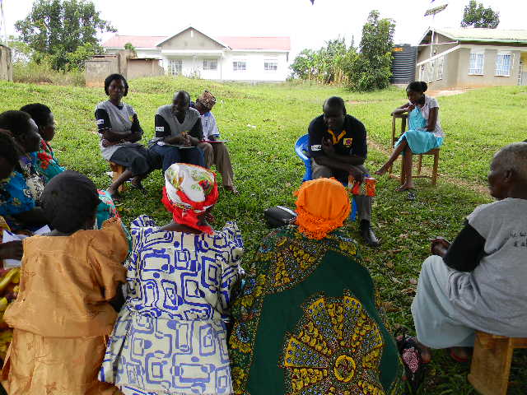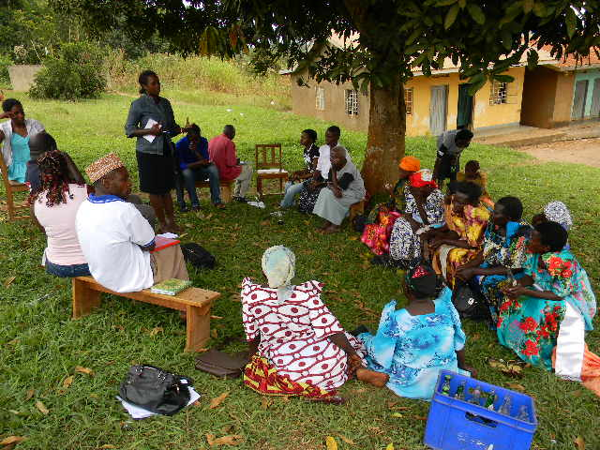
Mubende cluster conducting a dialogue with Myanzi and Nalutuntu Traditional Birth Attendants at Myanzi HC iii
Mrs. Mangeeri Musaazi who changed from being a TBA to a Village Health Team gave her testimony on how she was transformed and every TBA left when we had agreed that they willnot repeat the practice again and responsibility was given to Focal persons and Health Inspector so that incase they find mothers in their premises they will pay a fine of 1M and later imprisoned.

In the evening the team had to set to Kasambya village where we went with the media (NTV) to interview one of the TBAs (Nnalongo) who had inserted a stick in a mother and damaged her uterus.
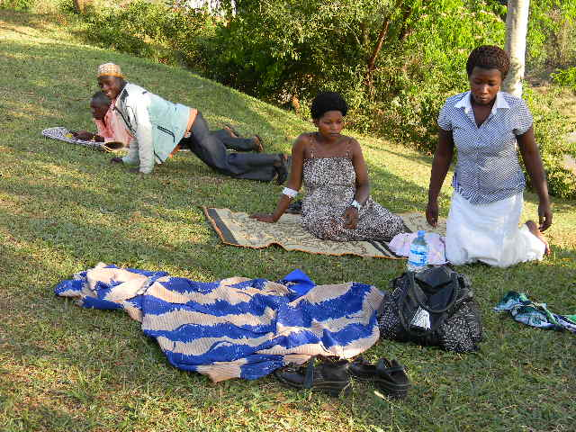 A 20 year old mother whom they had pluged a stick and damaged her uterus when she had gone to deliver from a TBA in Kasambya village. She was being attended to by health workers in Kiganda HCIV
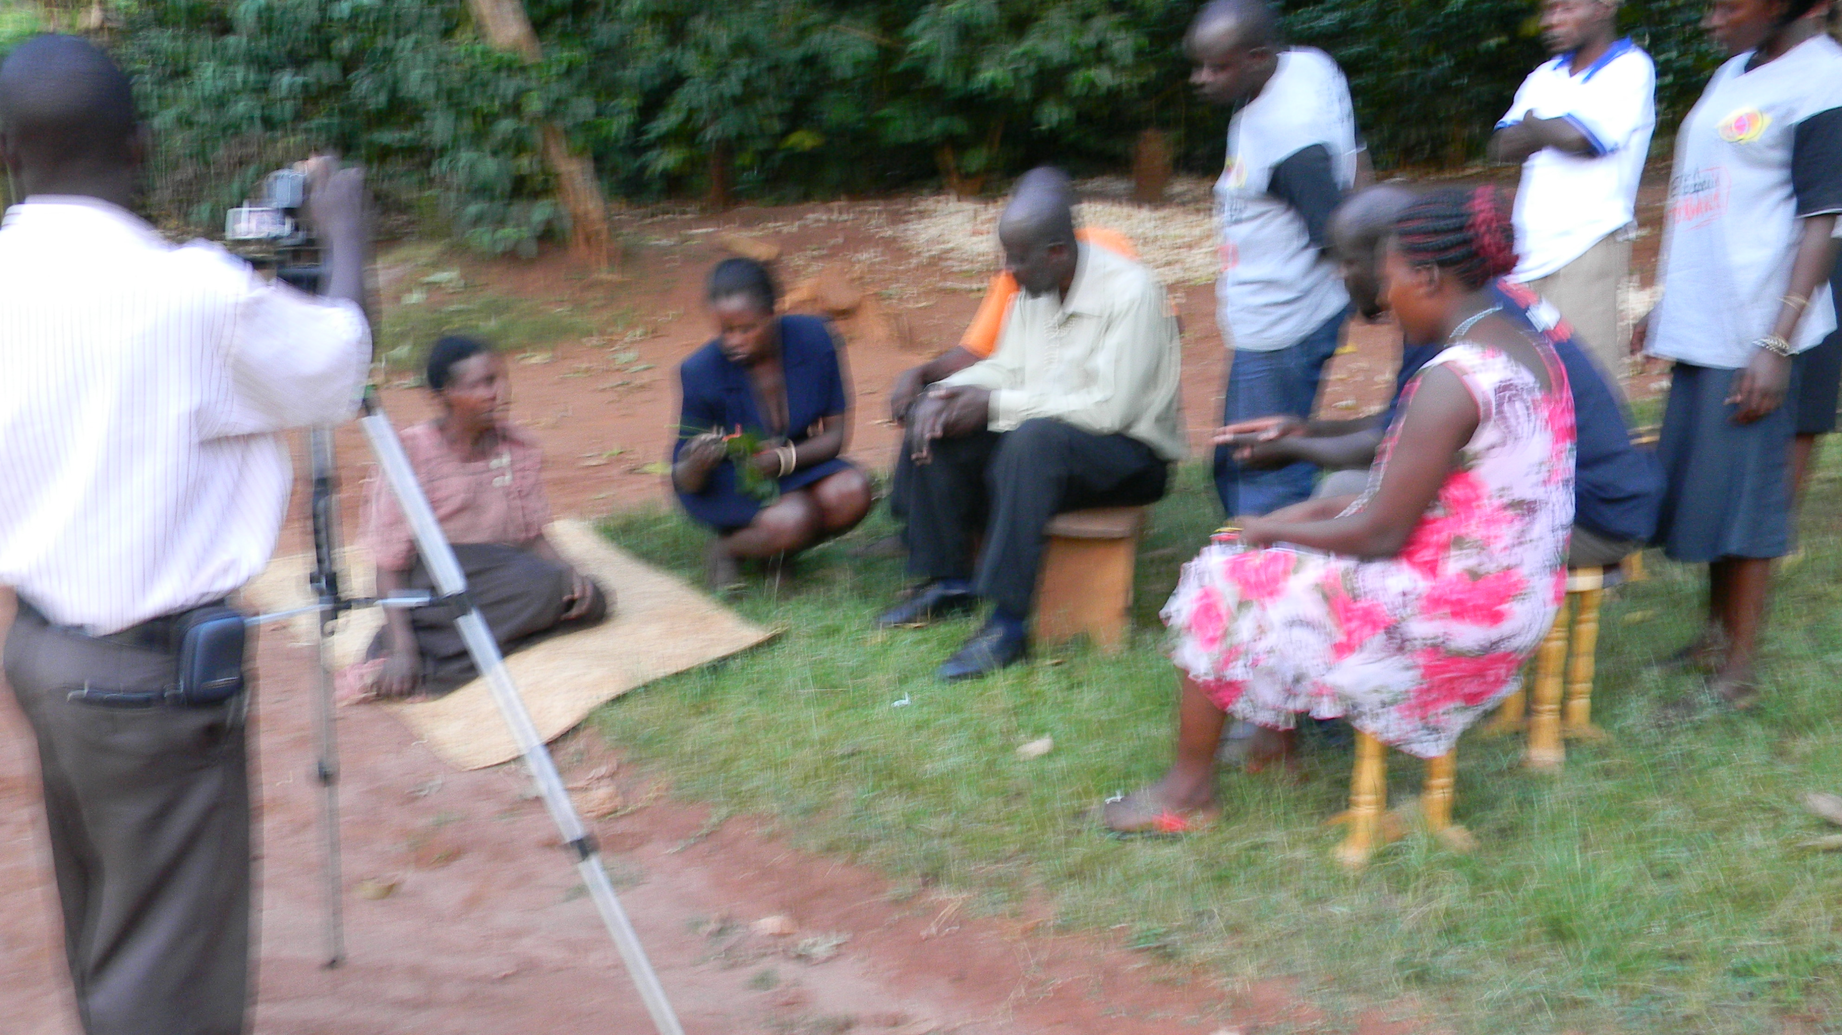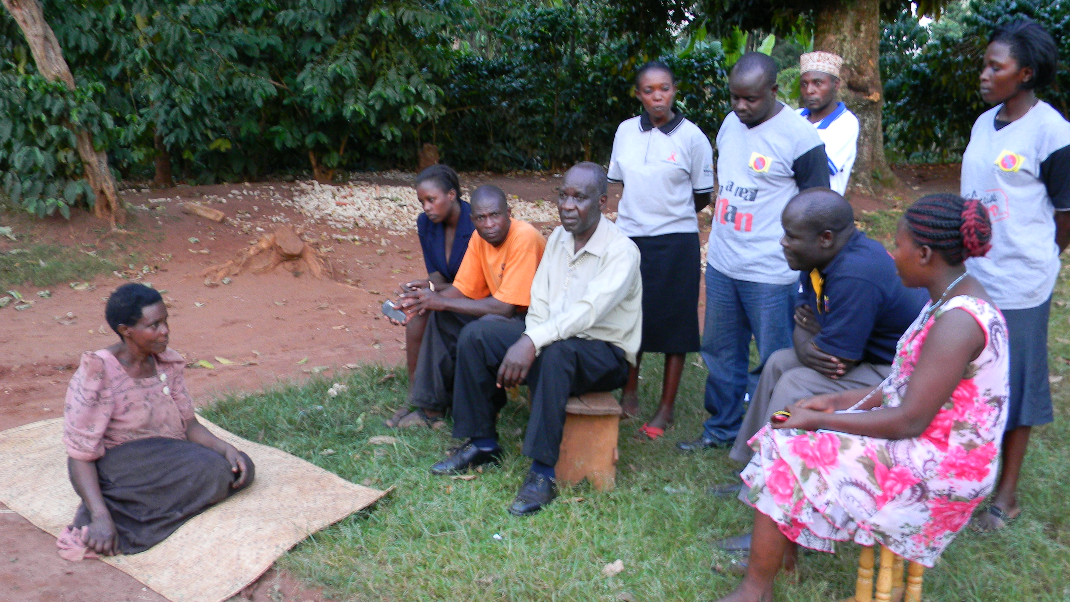 The team with NTV visiting this TBA who had pludged a stick to a mother and damaged her uterus. She even showed us the stick she uses to plug in mothers who deliver from her premises.

9th March the team returned back to Kampala

2.2 Result 2: Good access to and high utilization of MSRH services in target communities
Response from UNHO
2.3 Result 3: Key duty bearers held accountable for delivery of MSRH services in target areas
Response from UNHCO

2.4. Advocacy progress: report on the indicators below using the questions;
- Is there evidence and signs of enhanced advocacy effectiveness and opportunity?

As Mubende cluster (SAU and UNHCO) came up with an operation of stopping all the practices of Traditional Birth Attendants in our areas of implementation that is Kiganda, Nalutuntu and Myanzi. This operation has been supported by local leaders, Health workers and the incharge sub health district. A practical example was in Nalutuntu where the team made an operation with the support of Nalutuntu subcounty chief, Chairman Health Committee Kiganda, Midwife from Kiganda and Incharge subhealth district and Nnalongo Mulura (TBA) was asked to send all the mothers found in her premises to Kiganda Health center iv later we took her to Kakungube police station where she made a statement that there will no more deliveries in her premises. Next day we found these mothers at Kiganda Health center iv three (3) of them had delivered normaly and one had a C- section and indicator to show that a mother and her new born were to lose their lives at Nnalongos premises.

The team at Kakungube police station with a TBA in a (Blue gomesi). Nalutuntu subcounty chief was much supportive in this operation (in ablue shirt)

Kyakasengula Health Center iii in Nalutuntu subcounty has reached a completion stage and the Office of the Prime Minister has handed it over to Mubende district Health officials for implementation. This will reduce the distance mothers’ travel from Nalutuntu to Kiganda HCIV and Myanzi HC iii since Nalutuntu Sub County has only been having Health centre iis which are not allowed to conduct any deliveries according to the Ministry structures.

During the community dialogue held at Kakungube HCii Nalutuntu the Subcounty Chief informed the community that renovation funds for Mirembe HCii has been put in the 2013/2014 subcounty Financial Budget. This was lobbied from the community dialogue which was held last year at Mirembe Health center ii.

Through the community empowerment Kakungube HCii has not been having power but they held their Member of Parliament Hon Nyombi Thembo accountable for not having power. He has therefore connected power to this health facility.
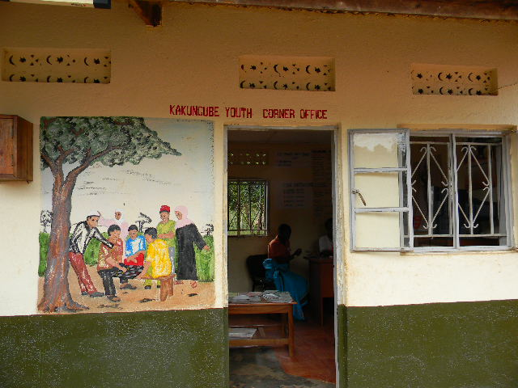 A youth corner providing youth friendly services to the youths in Kakungube parish. We have also partnered with them for the betterment of maternal health among the youths.

Recruitment of health workers has been evidenced in Kiganda HCIV where they have currently recruited more 4 midwives now having 7 midwives, Misozi HCiii has got an incharge and a Laboratory technician and Myanzi HCiii has got a Laboratory technician and a midwife.

- What change has there been and how did it come about?

Mothers have been dying from the TBAs premises and the delays practiced by them leading to deaths as they approach Health centers. Others have been using sticks to deliver mothers and a practical example was in Kiganda HCIV where the mother was brought and her uterus had been damaged. The other mother died with her twins for having delayed at Nnalongos (TBA) home in Nalutuntu as she was approaching Mubende Hospital. SAU and UNHCO got support from all the local authorities, Health workers and Incharge sub health district. The operation is still continuing with the supervision from Focal persons, Sub county Health Assistants and Police. There is been an increase in the number of referrals from TBAs of Nalutuntu to Health centers and Hospitals, evidence is the number of deliveries in kiganda HCIV where the number has increased from 23 to 43 deliveries a month.
Mirembe Health center ii was in poor condition and it lacked renovation therefore when we conducted a community dialogue at Mirembe HCii the community and Health workers demanded for a renovation of their facility. The sub county chief pledged to work on it and in the community dialogue that we held on 5th March 2013 he said he fulfilled his pledge by putting the renovation funds for the facility in 2013/2014 Subcounty annual budget.
Kakungube HCii did not have power but due to community demand the area MP Hon Nyombi Thembo was held accountable and had to connect power to the health facility.
- What was the role of the MH project in securing this outcome?

MHP implementing partners in Mubende district (SAU and UNHCO) decided to come up with an operation stopping TBA practices from our areas of implementation that is; Kiganda, Nalutuntu and Myanzi sub counties. This was based on a mother delayed in a TBAs home (Nnalongo Mulura) from Nalutuntu who died with her twins when approaching Mubende Hospital. Another mother from Kasambya village, her uterus was damaged by a TBA who used a stick to help in delivering. Operation is still continuing with the support from local authorities, health workers, Chairman HUMC and In charge sub health district. Supervision will be done by MHP focal persons, S/C Health Assistants and S/C police.
A community dialogue that was held at Mirembe HCii conducted by SAU and UNHCO last year where the community and health workers demanded for the renovation of their facility and it yielded results when the sub county chief remarked on 5th March 2013 in a community dialogue that was conducted by SAU at Kakungube HCii that the renovation funds for Mirembe HCii have been put in the 2013/14 financial budget.
The continued sensitization meetings conducted by CORPS have enabled to empower the community to demand for quality services this was evidenced in Kakungube HCii where the area MP was tasked to provide power for the facility and he has connected the power.

- What change has there been in the focal institutions (at community, district or national level) for the MH project and how did it come about?

At Community level
Traditional Birth Attendants in Kiganda, Nalutuntu and Myanzi sub counties are no more conducting any deliveries from their premises. This was a directive from District Health Officials spearheaded by UNHCO and SAU team.
Mirembe HCii is to be renovated this was a community and health workers demand from the community dialogue which was held at Mirembe HCii last year conducted by SAU and UNHCO. The sub county chief has put the renovation funds in the 2013/14 financial Budget.
District level
The district has recruited health workers in different categories examples; In Kiganda HC iv they have posted another Doctor making it two, four midwives making it seven, a Laboratory technician. In Misozi HC iii they have posted an in charge and a laboratory technician. In Myanzi HCiii they posted a Midwife and a Laboratory technician.

Kyakasengula HCiii in Nalutuntu has reached the completion stage and the Office of the Prime Minister has handed over the facility to the District Health Officials for implementation and posting of health workers.

The Incharge sub health district promised to support the new incharge in Misozi HCiii to sort out all the problems facing the facility such as late coming of the health workers, hand over duty, health workers attitudes towards the community and absenteeism among health workers.

National Level

At National level 500 health workers have been recruited and Health Center IV Doctor’s salaries have been increased from 900,000/= to 2.5/=Millions an indicator to show that there was great advocacy at National level.

The 24 Billion Mama kits were distributed this was discovered during our supervision exercise conducted in our areas of operation. The beneficiaries confessed that they do get them plus mosquito nets. Although the health workers were complaining that after giving them these mama kits some mothers do not come back to health centres for delivery. They have resolved this by distributing these mama kits at the fourth antenatal visit.

- What was the role of MHP in securing this outcome?

This was due to the frequent meetings held with other coalition partners under petition 16. Conducting monitoring and supervision of the recruitment process, distribution of the 24 mama kits and the supplementary budget.

2.4.1 Signs of positive change in key audiences' at national and district levels in support of actions geared towards improving maternal health.
National Level

At National level 500 health workers have been recruited and Health Center IV Doctor’s salaries have been increased from 900,000/= to 2.5/=Millions an indicator to show that there was great advocacy at National level.

The 24 Billion Mama kits were distributed this was discovered during our supervision exercise conducted in our areas of operation. The beneficiaries confessed that they do get them plus mosquito nets. Although the health workers were complaining that after giving them these mama kits some mothers do not come back to health centres for delivery. They have resolved this by distributing these mama kits at the fourth antenatal visit.

District level
The district has recruited health workers in different categories examples; In Kiganda HC iv they have posted another Doctor making it two, four midwives making it seven, a Laboratory technician. In Misozi HC iii they have posted an in charge and a laboratory technician. In Myanzi HCiii they posted a Midwife and a Laboratory technician.

Kyakasengula HCiii in Nalutuntu has reached the completion stage and the Office of the Prime Minister has handed over the facility to the District Health Officials for implementation and posting of health workers.

The Incharge sub health district promised to support the new incharge in Misozi HCiii to sort out all the problems facing the facility such as late coming of the health workers, hand over duty, health workers attitudes towards the community and absenteeism among health workers.

2.4.2 Signs of positive change at district level with actions that respond to maternal health needs of communities

District level
The district has recruited health workers in different categories examples; In Kiganda HC iv they have posted another Doctor making it two, four midwives making it seven, a Laboratory technician. In Misozi HC iii they have posted an in charge and a laboratory technician. In Myanzi HCiii they posted a Midwife and a Laboratory technician.

Kyakasengula HCiii in Nalutuntu has reached the completion stage and the Office of the Prime Minister has handed over the facility to the District Health Officials for implementation and posting of health workers.

The Incharge sub health district promised to support the new incharge in Misozi HCiii to sort out all the problems facing the facility such as late coming of the health workers, hand over duty, health workers attitudes towards the community and absenteeism among health workers.

2.4.3 Signs of positive changes at national level (MoH, Parliament and general political leadership) in response to maternal health improvements proposed by the MHP partners.
Tabel 4: Progress on the work plan (show in brief the status of implementation of each planned activitiy for the period under review)
Result areas/Objectives | Planned activities | Actual | Variance and Mitigation measures
Result 1:  Awareness and demand | 180 Community sensitisation meetings | 301 | We exceeded the set target.
Result 1:  Awareness and demand | Support supervision | One | It was successfully achieved as a team.
Result 1:  Awareness and demand | One Quarterly district stakeholders meeting | One | It was successfully achieved
 | Community dialogues | One | It was successfully achieved.
 | Radio talk show | Three | They were all done successfully
 | Spot Messages | 180 | They were all done successfully
 | Dram show | 1 | It was done successfully
Result 2:  Access and utilisation | Response from UNHCO
Result 3: Accountability | Response from UNHCO
Section 3:
3.1 Lessons learnt
- Working as a team yields results this was evidenced in the joint supervision which was carried out in Nalutuntu Subcounty.
- When the community is empowered they can demand for quality services this was evidenced in Kakungube H ealth center ii when the community held their area Member of Parliament Hon Nyombi Thembo to connect for them power which he has done.
- Community dialogues also yield results this was evidenced in the community dialogue conducted at Mirembe Health centre ii where the community and Health workers demanded the Subcounty to renovate their Health centre and the sub county chief reacted positively because he has put these funds in the 2013/14 Financial budget.
- It has been realised that men mostly attend drama shows and community dialogues therefore it will ideal if we increase drama shows and community dialogues and we target them.
3.2 Challenges
What are the main challenges and their implication on the achievement of the project results?
- We discovered that some resource persons in Kyakatebe parish were not performing well.
- It was identified that Kakungube HCii as a facility and the maternity ward in particular does not have water to run the daily activities.
- There is delay of the Primary Health Care funds from the district to the Subcounty.
- Although there is an increase in the number of attendances in both group and individual sensitisation meetings turn up for men is still low.
3.4 Recommendations
Which action should be taken to address the challenges? (They must be feasible and in the means of the project, they should also answer the challenges)
- We therefore recommended that it will be vital for the Focal person to take close supervision of the sensitisation meetings conducted so that they improve their performance.
- It was recommended that the community must also submit in their request with the help of their village chairpersons to the sub county so that they can put the water issue in the sub county budget 2013/2014.
- Delay of the Primary Health Care funds will involve continuous lobbying at the Ministry, District and Sub county level to release these funds in time.
- We can increase more drama shows and community dialogues so as we can target men plus conducting only male sensitisation meetings.

3.5 Conclusions
Sicklecell Association of Uganda appreciates her cluster member Uganda National Health Consumers/users organisation (UNHCO) for being a good teammate during the implementation of all activities because whichever activity implemented we did it as a team. For example during the community dialogue at kakungube HCii on 5th March Nalutuntu, supervision exercise in all the four parishes of Nalutuntu Subcounty on 6th March, quarterly district stakeholders meeting at Kiganda HCIV and a radio talk show on Heart FM 7th March, A drama show at Gayaza in Kiganda Subcounty. Traditional Birth Attendants meeting at Myanzi HC iii and all the operations of stopping TBAs from conducting any deliveries we did them as a team. Therefore I request that lets keep the team spirit so as to achieve better results.
Annexes
- Work plan and budget for the next period
- Cash request for the next period
- Success story (optional)
SUCCESS STORIES IN NALUTUNTU SUBCOUNTY
- Kakungube HC ii had no Electricity at the facility but with the community empowerment from the community resource persons and the focal person. They held the Member of Parliament accountable for the quality services needed by the community. Hon Nyombi Thembo the area Member of Parliament agreed to connect power to this facility which he has done.
- Kyakasengula HCiii has been completed by the Office of the Prime Minister and handed over to Mubende District Health Offices for proper implementation of the services offered by a Health Centre iii.
Kyakasengula HC iii in Nalutuntu Subcounty
- Mubende cluster spearheaded operations to stop all TBAs working in Mubende district and this has been successfully done because we have got all the support from local authorities, Health workers, Chairman Management committee Kiganda HC IV, Assistant DHO and incharge sub health district. A practical example was in Nalutuntu where the team visited Nnalongo (TBA) and ordered all mothers in her premises to go to Kiganda HC IV for delivery. The TBA was taken to police to make a commitment that she will no longer conduct any deliveries from her premises. The next morning we found these mothers at Kiganda HCiv under the supervision of skilled midwives and one mother had undergone a C- section. These mothers promised never to go for any delivery from a TBAs home.
Mubende cluster with a TBA at Kakungube police station.
- Renovation funds for Mirembe HC ii have been allocated in the 2013/14 financial budget this was as a result of MHP community dialogue that was held at Mirembe HC ii last year which was conducted by SAU and UNHCO.

