
MATERNAL HEALTH PROJECT 2010 - 2013

Name of Organization: Sicklecell Association of Uganda Date of Submission: 7th /July /2013

Reporting period: 1st April 2013 to 7th July 2013 District cluster: Mubende Sub county: Nalutuntu
Responsibility | Name | Title | Telephone Number | Email | Signature
Prepared by | Sentamu Edward | Program Officer | 0782963611 | eddiese2002@yahoo.com
Reviewed by | Jackie Nampijja | Acting Executive Director | 0776635515 | jackilove@yahoo.com | 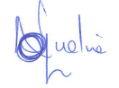
Instructions
- Report data on the meetings where the numbers of attended can be obtained. Also include data where individuals receive messages either in small groups or as individual entities.
Section 1
Introduction
The maternal Health Project is implemented by 9 partners in 8 districts in Uganda where Sicklecell Association of Uganda and Uganda National Health consumers Organisation are cluster implementers in Mubende district. This project focuses on a rights based approach and a cluster model in implementing its activities. All the activities for the period from April to June were successfully implemented

16th – 19th April SAU program Officer Mr. Sentamu Edward and Focal person Mr. Sebunya Amjad were part of the capacity building training on sexuality education, Human Rights, Gender Based Violence and Family Planning which was facilitated by RFSU at Arch Apartments.

24th April 2013. The SAU team that comprised of the program officer Mr. Sentamu Edward, the Focal Person Mr. Sebunya Amjad and the representative of the Executive Director Ms. Nampijja Jacqueline conducted a community dialogue on Maternal, Sexual and Reproductive Health Rights (MSRHR) focusing on dangers of delivering from a Traditional Birth Attendant which took place at Mirembe Health centre II. We had 84 participants and these included the Chairperson Local council 111 Mr. Kamulegeya Peterson, the Health Unit Management Committee, community resource persons, Health workers and the community members.

25th April 2013. SAU also conducted support supervision on MSRHR with the twenty community resource persons in Nalutuntu Subcounty Mubende district where their performance, challenges and way forward were discussed.

8th May 2013 SAU and UNHCO conducted a quarterly district stakeholders meeting on Maternal Sexual and Reproductive Health Rights at Mubende District Headquarters and later travelled to Myanzi Health centre III for a monitoring and Evaluation visit.

9th May 2013 SAU, UNHCO and the District Health Team travelled to Mirembe HCII at 9.00 am for a Monitoring and Evaluation visit in Nalutuntu Subcounty. At 2.00 pm the team travelled to Kiganda HCIV for the same activity.

10th May 2013 SAU and UNHCO had a feedback meeting at Mubende District Headquarters with the District Health Team disseminating results from the Monitoring and evaluation visit.

7th and 10th June 2013 SAU Program Officer Mr. Sentamu Edward attended a capacity building workshop on documentation of case studies facilitated by RFSU consultant Tim Lee at hotel Africana organised by UNHCO.

Table 1: Achievements on the targets for the quarter
Result areas/Objectives | Indicator | Actual achievement (numbers ) | Deviation from plan | Reasons for deviation and remedial action
Result 1:  Awareness and demand | Indicator R1.1: Number of community sensitisation meetings held to disseminate MSRHR information | 305 sensitisation meetings and topics included; importance of Antenatal care, male involvement, Family planning, danger signs of pregnancy, patient rights, PMTCT, Sicklecell disease and pregnancy, delivering in Health centres, HIV/AIDS testing, postnatal care, dangers of early pregnancy among youths, dangers in abortion, personal hygiene. | We had planned 180 sensitisation meetings | We exceeded our target because of an increase in the number of men who participated in the sensitisation meetings.
Result 1:  Awareness and demand | Indicator R1.2: Attendances at community sensitisation meetings (groups) | Males were 1817 and Females were 2847 totalling to 4664 participants and sensitised on the following topics; importance of Antenatal care, male involvement, Family planning, danger signs of pregnancy, patient rights, PMTCT, Sicklecell disease and pregnancy, delivering in Health centres, HIV/AIDS testing, postnatal care, dangers of early pregnancy among youths, dangers in abortion, personal hygiene. | We had planned 1620 participants | We exceeded our target this was because the resource persons conducted more group sensitisation.
Result 1:  Awareness and demand | Indicator R1.3: Attendances for individual information and dialogue with MHP community resource persons (individuals) | Males were 1420 and Females 2162 totalling to 3582 and topics sensitised included; importance of Antenatal care, male involvement, Family planning, danger signs of pregnancy, patient rights, PMTCT, Sicklecell disease and pregnancy, delivering in Health centres, HIV/AIDS testing, postnatal care, dangers of early pregnancy among youths, dangers in abortion, personal hygiene. | We had targeted 1000 people | We exceeded our target because our resource persons increased on the number of home visits in their given parishes.
Result 2:  Access and utilisation | Indicator R2.1: Number of outreaches conducted | Response from UNHCO
Result 2:  Access and utilisation | Indicator R2.2: Number of health facilities supported to conduct MSRH service and information outreaches | Response from UNHCO
Result 2:  Access and utilisation | Indicator R2.8: Maternal deaths recorded at community level | Response from UNHCO
Result 3: Accountability | Indicator R3.1: Number of health unit management committees sitting at least 4 times a year. | Response from UNHCO
Result 3: Accountability | Indicator R3.4: Number of health facilities (Health Centre 3 or 4) with at least one functional feedback/redress mechanism in place (i.e. Complaint desks, suggestion boxes, disciplinary committees, meetings etc). | Response from UNHCO
Table 2: Cumulative progress to date (Total numbers since start of the project to the time of current reporting)
Result areas/Objectives | Indicator | Cumulative achievement (numbers ) | Comments
Result 1:  Awareness and demand | Indicator R1.1: Number of community sensitisation meetings held to disseminate MSRHR information | 1157 sensitisation meetings and topics covered included; importance of Antenatal care, male involvement, Family planning, danger signs of pregnancy, patient rights, PMTCT, Sicklecell disease and pregnancy, delivering in Health centres, HIV/AIDS testing, postnatal care, dangers of early pregnancy among youths, dangers in abortion, personal hygiene. | The tremendous increase in the number of meetings was due to the increased mobilisation from local leaders, religious leaders and Health workers.
Result 1:  Awareness and demand | Indicator R1.2: Attendances at community sensitisation meetings (groups) | 15637 group sensitisation meetings and topics included; importance of Antenatal care, male involvement, Family planning, danger signs of pregnancy, patient rights, PMTCT, Sicklecell disease and pregnancy, delivering in Health centres, HIV/AIDS testing, postnatal care, dangers of early pregnancy among youths, dangers in abortion, personal hygiene. | The increase in group sensitisation was due to the improved mobilisation skills from the resource persons.
Result 1:  Awareness and demand | Indicator R1.3: Attendances for individual information and dialogue with MHP community resource persons (individuals) | 9838 Individual sensitisation meetings topics covered included; importance of Antenatal care, male involvement, Family planning, danger signs of pregnancy, patient rights, PMTCT, Sicklecell disease and pregnancy, delivering in Health centres, HIV/AIDS testing, postnatal care, dangers of early pregnancy among youths, dangers in abortion, personal hygiene. | This increase was due to the improved male participation in the individual meetings.
Result 2:  Access and utilisation | Indicator R2.1: Number of outreaches conducted | Response from UNHCO
Result 2:  Access and utilisation | Indicator R2.2: Number of health facilities supported to conduct MSRH service and information outreaches | Response from UNHCO
Result 2:  Access and utilisation | Indicator R2.8: Maternal deaths recorded at community level | Response from UNHCO
Result 3: Accountability | Indicator R3.1: Number of health unit management committees sitting at least 4 times a year. | Response from UNHCO
Result 3: Accountability | Indicator R3.4: Number of health facilities (Health Centre 3 or 4) with at least one functional feedback/redress mechanism in place (i.e. Complaint desks, suggestion boxes, disciplinary committees, meetings etc). | Response from UNHCO
Note: For indicators; R2.2, R3.1 and R3.4; the cumullative will initially increase, once the total maximum number available is reached there will be not cummulatives, instead the the number will remain the same if there are no declines.
Table 3: Mass Media
Type | Number | Topic/Theme
E.g Radio talk shows  This is a joint activity implemented by both SAU and UNHCO on 102.3 Heart FM Mubende | 2 Radio talk shows | The role played by HUMCs at a health facility.  Consequences of delivering from Traditional Birth Attendants.
Radio spot massages  They are played on 102.3 Heart FM Mubende | 180 messages | Male involvement, dangers of delivering from TBAs, attending ANCs and delivering from Health centers
Drama shows etc | 2 Drama shows | Dangers of delivering from TBAs, male involvement, roles of VHTs, Family planning, delivering from Health centers, attending ANCs, community participation, importance of sensitisation meetings,

Section 2: Narrative page
Provide a detailed description on how all activities were implemented per result area and what was achieved as a result of implementing the activities.

2.1 Result area1: Target communities aware of their rights and demand quality MSRH services
Community dialogue on 24th April 2013
Sicklecell Association of Uganda conducted a community dialogue at Mirembe Health centre II the only government facility located in Nalutuntu Subcounty. We had 84 participants these included three Health workers, Local council III Chairperson, Health Unit Management Committee, Community Resource Persons and Mirembe community. Our main theme was about why mothers still give birth from Traditional Birth Attendants.
We had communication from the Local Council 111 chairperson who appreciated the Maternal Health Project and the Community Resource Persons for the wonderful work done through sensitizing the community both at group and individual level about their rights to demand for quality services.
He emphasised on the key issues which the Community Resource Persons should put emphasis on, like the danger signs of pregnancy and delay of expecting mothers at home. He has got reports that mothers are being sent away from Mityana Hospital back to Mubende district this causes delay leading to the death of a mother and the newborn. Male involvement has improved but to a limited extent here in Nalutuntu therefore the Community Resource Persons have a greater role to play so as to bring these men on board to know their responsibilities, he suggested that let there be men only sensitisation meetings.
Sicklecell Association of Uganda program officer gave a brief background about the existence of Traditional Birth Attendants in Uganda and commented on the current operations which are carried out by SAU and Uganda National Health Consumers Organisation in Mubende district on Traditional Birth Attendants. He cited examples of Nnalongo Mulura of Nalutuntu, Nnalongo Nalufu of Kiganda Subcounty and Nnalongo of Kasambya who were taken to Police to make statements regarding their negligence which led to the death of mothers and their newborn.
Participants’ response to why mothers still deliver from TBAs
- Mothers fail to raise money for transport to health facilities.
- Mothers still believe in witchcraft therefore Traditional Birth Attendants use it as trick to stay with these mothers at their premises till delivery period.
- Sometimes the attitude of Health workers for example at Myanzi Health Centre III they always shout at them.
- They live and stay with these Traditional Birth Attendants therefore its easier for mothers to deliver from their premises.
- Men fail to perform their responsibilities such as providing all the necessary requirements needed by the expectant mother and yet they are needed at a Health facility therefore they resort to deliver from Traditional Birth Attendants.
- Some women fear to be tested for HIV/AIDS because they will ask them to come with their Husbands yet most men fear that test.

Way forward
- It was agreed on that it’s the responsibility of both the Mother and Father to do proper preparations for the Newborn. By saving some money for transport and buying requirements.
- Sicklecell Association of Uganda program Officer informed the community about the operations conducted by both SAU and UNHCO on Traditional Birth Attendants where some of them have been taken to Police to make statements such as Nnalongo Mulura of Nalutuntu and Nnalongo Nalufu of Kiganda. Anyone found in these premises will also be taken police.
- Myanzi Health Workers attitude was to be dealt with informing our Implementing partner UNHCO and the Health Unit Management Committee to dialogue with the Health workers and find out if there is a possibility for change of attitude.
- They requested for the completion and operationalisation of Health Centre III at Kyakasengula village for easy accessibility and utilisation of Maternal Sexual and Reproductive Health services and avoid visiting Traditional Birth Attendants.
- They asked resource persons to start conducting only men sensitisation meetings because most men fear to go for the HIV/AIDS testing. This will help them know the importance of their involvement

Support Supervision on 25th April

Health Workers
- It was indentified that resource persons need to work closely with the Health workers so as to improve on primary Health care of the community
- We discovered that there is a tremendous improvement in record keeping at Kyakatebe Health Centre II.
- Sometimes the facility faces absenteeism of the Midwife this affects the Antenatal care and Family planning services.
- Health workers do not have accommodation near the health facility, they travel a long distance from where they reside.
- Health workers at Kyakatebe have a positive attitude towards change.

Health Unit Management Committee
- The kyakatebe HUMC was oriented and they know their roles though they need more guidance and mentoring.
- They have sensitised the community on the use of Suggestion Box in a health facility.
- They also emphasised on closely working with the resource persons in Kyakatebe village.
- They took a decision on requesting the community to pay 500/= for cleaning the Health Facility compound.
- They normally have quarterly meetings at the facility and always put up the suggestions from the people although they normally use English which most the community do not know.
Community Resource Persons
- It was identified that their performance has improved this was based on the sampling exercise done in their areas of operation.
- They have also changed strategies of information delivery such as targeting only men sensitisation.
- They know the topics of sensitisation on Maternal Sexual Reproductive Health Rights.
- They lack referral letters but always refer mothers to Health centres.
- They have proper record keeping skills this was indentified from the Black Books given to them at the beginning of the project.
- They also conduct follow up services this was evidenced in their record Books where they write all pregnant mothers in their area and follow them up to delivery period.
Community
- The communities have been empowered to demand for their rights
- They also acknowledge that the resource persons reach them with topics such as Family planning, danger signs of pregnancy, Antennal care, avoiding to visit TBAs, proper hygiene and dangers of abortion.

Quarterly district meeting 8th May 2013

The meeting was chaired by the cluster leader for UNHCO and SAU Moses Kirigwajjo and introduced Voices for Health Rights Team to Mubende District Health Team. Monitoring and Evaluation Officer Mr. Mukulu Moses explained the progress of the project and the actions taken in the previous visit in which some were handled by the district and others by implementing partner’s for example the issues of health education improved with quality information used by resource persons. Progress identified in the area of immunisation and Human Resource, Sale of Mama Kits was cleared in Kiganda Health centre IV, Health Unit Management Committee at Kyakatebe was oriented but need more guidance and mentoring, Resource persons reporting to Health centres is still not enough, sharing radio programs with Implementing partners in Mityana was not yet solved. He later requested two District Health Team staff to join the VHR team for the monitoring and Evaluation visit in Myanzi Health center III , Kyakatebe Health center II and Kiganda Health Center IV. The District recommended Mr. Kawuma Charles (District Health Educator) and Mugume Trevor (District Health Inspector).

Monitoring and Evaluation report from Myanzi Health Center III, Kyakatebe Health Center II and Kiganda Health Center IV 8th – 10th May 2013

- It was observed that family planning uptake is still low; because people still have negative attitudes coupled with inadequate information, lack of skill to communicate Family planning messages by Village Health Teams and men are also particularly not supportive.
- Prioritise Post Natal Care at all levels – Kiganda allocated a midwife to the MHC clinic every Tuesday and Thursday to bridge this gap. All facilities were requested to make necessary arrangements for ensuring that PNC services are very vibrant.
- Exploring opportunities for using role models like Kiganda to mentor lower facilities
- Advocacy on the need to increase the content of the Mama Kit, Provision of electricity to Kiganda should be key.
- Safe Male Circumcision was stopped in Kiganda because of lack of reagents.
- Task shifting, absenteeism and late coming are to be wiped out by the district, HUMCs, In charges and Subcounty leadership to follow up on routine basis and keep actors appraised on the progress. This was evidenced in Myanzi HCIII and Kyakatebe HCII
- To intervene administratively by way of mentoring and coaching to help the team of health workers at Myanzi understand client provider partnership / relationships.
- Support HUMCs for Kyakatebe and Myanzi to become empowered especially when it comes to taking decisions within their realm and enforcement. A careful balance must be maintained not to turn them into fighters. The Kiganda success story can be helpful.
- The monthly charges at Kyakatebe was stopped forthwith unless proper process is used which may not cause problems for the service and the district politically.
- The district to provide transport – old motorcycle for the In charge at Kyakatebe HC II
- For implementing partners we need to map out and engage with other actors involved in Maternal Sexual and Reproductive Health Services.
- Strengthening Village Health Team Supervision.
- Myanzi and Nalutuntu improve on feedback not just producing the comments without response and the suggestion box at Myanzi must not have any other name other than suggestion box

Documentation workshop with RFSU consultant Tim Lee on 7th and 10th June 2013
Project Officers of implementing partners went through

2.2 Result 2: Good access to and high utilization of MSRH services in target communities
Response from UNHCO
2.3 Result 3: Key duty bearers held accountable for delivery of MSRH services in target areas
Response from UNHCO
2.4. Advocacy progress: report on the indicators below using the questions;
- Is there evidence and signs of enhanced advocacy effectiveness and opportunity?

At Kyakatebe Health Centre II, the Health Unit Management Committee and the In charge were charging each Health consumer 500/= for paying the facility cleaner. This decision was not in proper procedures because the community kept on complaining about this fee and nothing was done.

- What change has there been and how did it come about?
After sensitizing the community about their rights and demand for improved services they started requesting that if possible let them stop paying that fee because failure to pay that fee the in charge would not give them the service required. Later SAU conducted a dialogue and one community member raised her request that: “Is it possible for the Health Workers to stop charging us 500/= because when we do not pay it, we do not get the service”.

- What was the role of the MH project in securing this outcome?
During the Monitoring and Evaluation exercise at Kyakatebe HCII, the District team was part of this visit therefore we held a community dialogue and the community members raised this issue of charging 500/= and requested that if possible they can remove this charge. Mr. Kawuma Charles (A representative of the DHO) ordered the In charge and the HUMC to stop forthwith charging the patients the 500/= because this was not in proper procedure. They had to write to the Subcounty and the District.
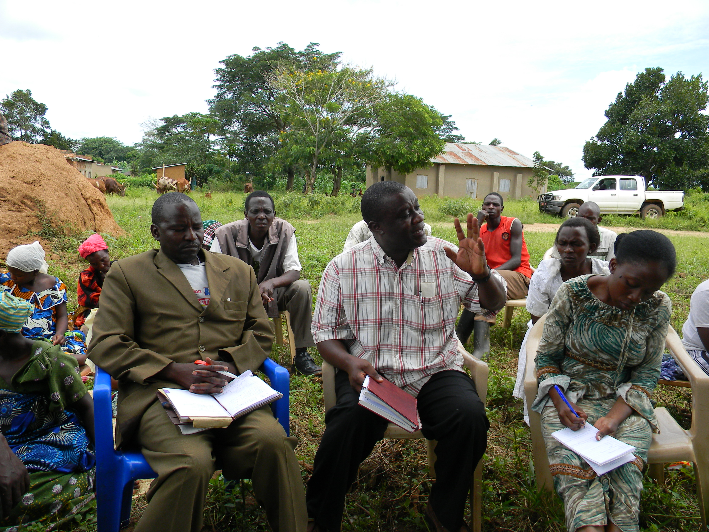 LC III Chairperson Nalutuntu S/C, The DHE(Center) Mr. Kawuma Charles making a directive of stopping the charge of 500/= for cleaning services from patients during a community dialogue at Kyakatebe HCII and SAU acting Executive Director noting it down.
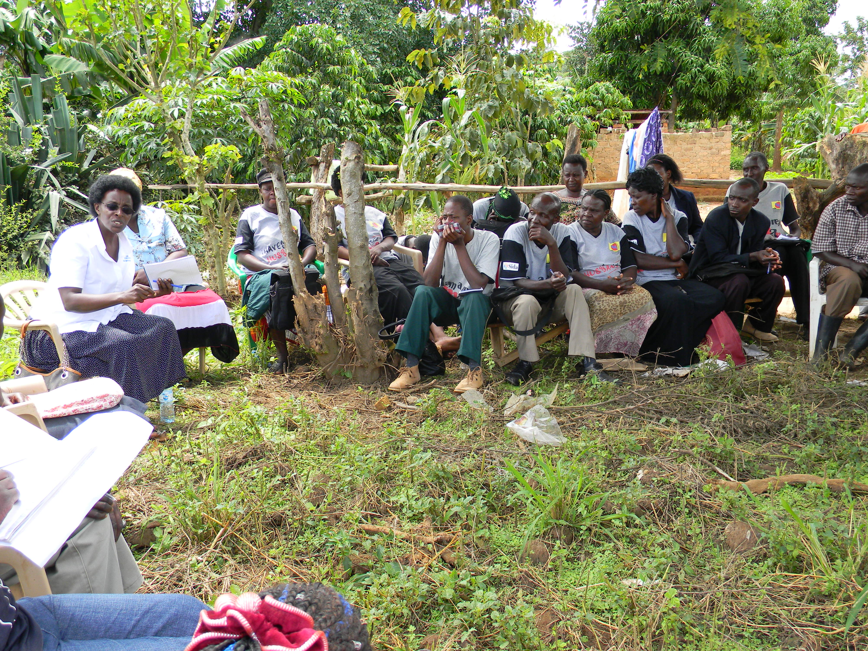UNHCO Executive Director was part of the community dialogue at Kyakatebe HCII.
- What change has there been in the focal institutions (at community, district or national level) for the MH project and how did it come about?

At Community level
The community of Kyakatebe Health Center II was being charged 500/= for cleaning services and failure to pay this fee they could not get the services needed at the facility but with the intervention of a Maternal Health Project with the District Health Team, the In charge and HUMC was ordered by the representative of the District Health Officer to stop charging the community that fee because it was not in proper procedure.
District level
- The support from the District Health Team of Mubende towards the improvement of quality Health care among the communities and focusing on Primary Health Care this was evidenced when the District Health Educator Mr. Kawuma Charles pledged to work closely with the Implementing Partners to reorient all Village Health Teams in the core aspects of VHT roles and MSRH to bridge knowledge and skills gaps indentified.
- The District pledged to intervene in task shifting, absenteeism and late coming of health workers especially in Myanzi and Kyakatebe Health centers.

National Level
- With other partners in Maternal Health we continued advocating for more recruitment of critical cadres such as anaesthetists, doctors, midwives, public health nurses and Laboratory assistants.
- We are urging Government to re-advertise the unfilled positions and conduct interviews with a view to filling them.
- Government to urgently recentralize the recruitment of health workers and management of health services in General Hospitals and Health centre IVs.
- Government to make Primary Health Care the first priority in Health Policy by strengthening the Village Health Teams.

What was the role of MHP in securing this outcome?

At community level this was because of the empowerment given to the people to know their rights and started demanding for quality services. This was in the community dialogue held at Kyakatebe HCII where the DHO representative ordered that the charging of 500/= for cleaning services must stop because of no proper procedure.
At District level this was because of the involvement of the District Health Team to be part of the Monitoring and Evaluation visits and some decisions were taken on spot. Mr Kawuma Charles (DHE) was quoted saying that; “I have liked the Maternal Health Project approach of involving us the District in the Monitoring and Evaluation exercise this is a sustainability method”.
At National Level this was through the partners working towards the same goal of reducing maternal mortality in Uganda. We have been having meeting with Health Budget committee at Parliament. We have also been engaged with the petition 16 court hearings.
2.4.1 Signs of positive change in key audiences' at national and district levels in support of actions geared towards improving maternal health.
National Level
- With other partners in Maternal Health we continued advocating for more recruitment of critical cadres such as anaesthetists, doctors, midwives, public health nurses and Laboratory assistants.
- We are urging Government to re-advertise the unfilled positions and conduct interviews with a view to filling them.
- Government to urgently recentralize the recruitment of health workers and management of health services in General Hospitals and Health centre IVs.
- Government to make Primary Health Care the first priority in Health Policy by strengthening the Village Health Teams.

District level
- The support from the District Health Team of Mubende towards the improvement of quality Health care among the communities and focusing on Primary Health Care this was evidenced when the District Health Educator Mr. Kawuma Charles pledged to work closely with the Implementing Partners to reorient all Village Health Teams in the core aspects of VHT roles and MSRH to bridge knowledge and skills gaps indentified.
- The District pledged to intervene in task shifting, absenteeism and late coming of health workers especially in Myanzi and Kyakatebe Health center.

2.4.2 Signs of positive change at district level with actions that respond to maternal health needs of communities

District level
- The support from the District Health Team of Mubende towards the improvement of quality Health care among the communities and focusing on Primary Health Care this was evidenced when the District Health Educator Mr. Kawuma Charles pledged to work closely with the Implementing Partners to reorient all Village Health Teams in the core aspects of VHT roles and MSRH to bridge knowledge and skills gaps indentified.
- The District pledged to intervene in task shifting, absenteeism and late coming of health workers especially in Myanzi and Kyakatebe Health center
2.4.3 Signs of positive changes at national level (MOH, Parliament and general political leadership) in response to maternal health improvements proposed by the MHP partners.
- The Budget Finance Committee recommended that the Government should come up with concrete deliberate plan to increase the number of critical cadres of health workers such as anesthetists, midwives, laboratory assistants in the country through anumber of measures, including a scholarship scheme.
- Government should use the reserve list assembled during the recently concluded recruitment process to fill vacant posts that were not taken up by those recruited. If the the reserve list is not adequate, Government should re – advertise the unfilled positions and conduct interviews with view to filling them.
- The ministry of Public service should urgently communicate to all Chief Administrative Officers to issue fresh appointment letters indicating the rentation allowance payable to health workers at health center IIIs and IVs.
- Government should review the recent enacted policy of pahsing out nursing assistants as well as comprehensive nursing training which has had negative effect on midwifery training and suspected to be a major factor leading to the escalation of maternal mortality rate.

Tabel 4: Progress on the work plan (show in brief the status of implementation of each planned activitiy for the period under review)
Result areas/Objectives | Planned activities | Actual | Variance and Mitigation measures
Result 1:  Awareness and demand | One community Dialogue | One was implemented successfully
Result 1:  Awareness and demand | 2 Drama shows | Two were implemented successfully
Result 1:  Awareness and demand | Support Supervision | It was done successfully
Result 1:  Awareness and demand | 2 Radio talk shows | These were implemented successfully
Result 1:  Awareness and demand | 180 spot messages | They were run successfully
Result 1:  Awareness and demand | 180 Sensitisation meetings | We exceeded the target by conducting 305 sensitisation meetings
Result 2:  Access and utilisation | UNHCO Response
Result 3: Accountability | UNHCO Response
Section 3:
3.1 Lessons learnt
- Involving the District Health Team in Monitoring and Evaluation exercise is the best way of sustainability.
- Decisions can be taken on spot when conduct a Monitoring and Evaluation exercise with the DHT a good example was the stopping of the in charge and HUMC at Kyakatebe HCII from charging the Health consumers 500/= for cleaning services.
- Providing feedback to the District is critical because this eases work for the district to make a follow up on some emergencies this was evidenced when there was an issue of selling antenatal cards at Myanzi HCIII the district reacted faster and gave the HUMC Chairman the Cards and left with them after the meeting to the Health Centre.
3.2 Challenges
What are the main challenges and their implication on the achievement of the project results?
- During the Monitoring and Evaluation exercise we identified that some health workers still possess a poor attitude towards the Health consumers and even if they are told to change they react badly this was evidenced at Myanzi Health Centre III.
- We also observed that family planning uptake is still low because of the negative attitude coupled with inadequate information / lack of skills to communicate Family planning messages by Village Health Teams. Men are particularly not supportive.
- There is still a challenge of prioritising Post Natal Care in all the facilities
- The death of our two midwives who have been working at Kyanamugera Health Center II under the support of church of Uganda support and Kakungube Health center II in support of Uganda Moslem Supreme Council. These have been working closely with our resource persons.
3.4 Recommendations
Which action should be taken to address the challenges? (They must be feasible and in the means of the project, they should also answer the challenges)
- About the health workers attitude it was resolved by the District Health Team that they will orient and talk the Myanzi Health workers for a positive change.
- Concerning Family planning the District Health Educator Mr. Kawuma Charles pledged to collaborate with implementing partners ton orient all the VHTs in the core aspects of VHT roles and MSRH to bridge knowledge and skills gaps indentified.
- Post Natal Care all facilities will make necessary arrangements for ensuring that PNC services are very vibrant as for the case of Kiganda where they allocated a midwife to the Maternal Health care clinic every Tuesday and Thursday to bridge this gap.
- We will lobby for a quick replacement from Church of Uganda and Uganda Muslim supreme council.
3.5 Conclusions
Teamwork is the best way of getting results. Putting the District Health Team at a fore front during the Monitoring and Evaluation exercise promotes sustainability.
Annexes
- Work plan and budget for the next period
- Cash request for the next period
- Success story (optional)
VIEW THE CASE STUDY TEMPLATE.

